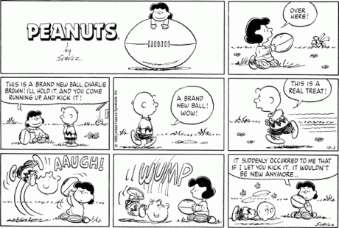  Charlie look at my new ball. | I’m going to kick it! |  | I don’t want him to kick my ball.
What happens next? Howe does Charlie and Lucy feel?
How can Lucy and Charlie and be sincere?

What happened to you this week? Can you make a comic about what happened?

- What happened?
- How did you feel?
- How did your friend feel?
- What did you do to tell your friend your feelings?

